Special Custom Order Form
xuchang mingli hair products co.,ltd
Xuchang science and technology center,yan’an road,
xuchang city,henna province,china.461000
Phone:0086-374-2281199 Fax: 0086-374-2281239
http://www.mltoupee.com e-mail:lotus1239@mltoupee.com
Please, fill this form out, and send it to us.
Name: Order Date:
Address:
Country:
Tel: Fax:
E-mail Address:
(when we receive your order, we will inform you by e-mail)
1. Hair:
Indian Human Hair ( )%, Chinese Human Hair ( )%
Kanekalon Synthetic Hair ( )%.
Hair Length: 5" ( ), 6" ( ), 7" ( )Other Length ( ) "
2. Size:
Standard Size (7"x 9"),other size( )
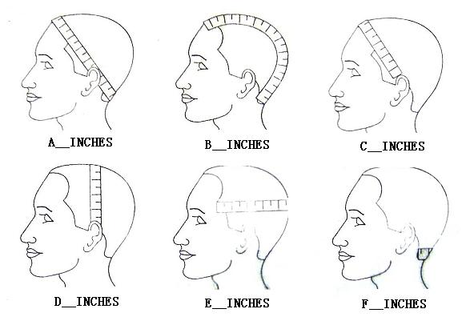
A____INCHES, B____INCHES, C____INCHES,
D____INCHES, E____INCHES, F____INCHES
3. Base: Click here to see base samples.
Model:______, Custom Duplication ( ) , Return Used Hair Piece ( )
4. Hair direction, parting: Click here to see image samples
Left part ( ), Right part ( ), Center part ( ),
Left crown ( ), Right crown ( ), Center crown ( ),
Left comb over ( ), Right comb over ( ), Free Style ( ), Front to back ( ).
5. Hair Curl: Click here to see more information
Straight ( ), Slight Wave 30mm ( ), Standard 25mm ( ), Tight Wave 20mm ( ),Loose Curl 15mm ( ), Tight Curl 10mm ( ), Afro Curl 2-5mm -synthetic only- ( ).

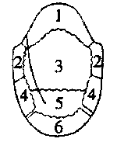
6. Hair Density:
All of same densities:
Heavy 150% ( ), Medium Heavy 120% ( ), Medium 100% ( ),Medium Light 80% ( ), Light 60 % ( ).
Each of different densities:
7. Hair Color:
All of same colors ( ), Each of different colors ( ),Gray Hair ( ) %
*Our gray hair is synthetic(recommend).

8.Template（to make template）
if order full wig which the base like full wig base1,the template must need.

Description:
______________________________________________________________________________________________________________________________________________________________________________________________________________________________________

